|  |  |  |
| --- | --- | --- |
| **Attribute** | **Parameter value** |  |
| Product Catalogue | Slide switch |  |
| Rated Current (DC) | 3A |  |
| Rated Voltage (DC) | 125V |  |
| Rated Current (AC) | 3A |  |
| Rated Voltage (AC) | 125V |  |
| Circuit structure | Single-action double-throw |  |
| Installation method | Crested plug |  |
| Mechanical lifespan | 10000 |  |
| Switch color | black |  |
| Slide knob shape | Rectangular columnar |  |
| Pin style | PC pin |  |
| Working temperature | -40℃~+85℃ |  |
| Switch length | 13.5mm |  |
| Switch width | 6.6mm |  |
| Switch height | 6.3mm |  |

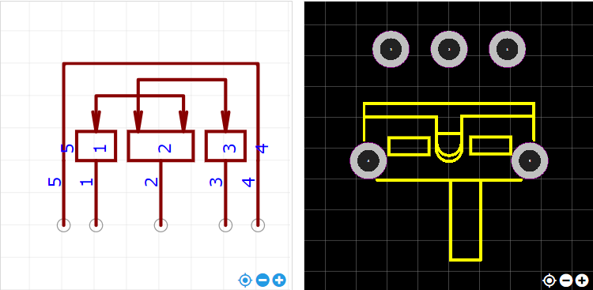

<https://item.szlcsc.com/724367.html>